SQL Exercise 2

**Purpose:** Nine SQL exercises will be released throughout the quarter. These assignments will help you connect and manipulate a database through Python. Python-to-SQL is a parallel strand of knowledge that you would gain in this class.

**Reference:** 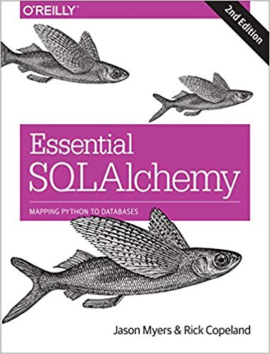

**Code:** Time to practice! Try the code below and get it to work. The code is pre-tested and should run “as is.” Verify what you type if an error persists. Press “Run” to every time you completed a jupyter cell. Because you already have content knowledge of what is a database, most of the code are self-explanatory.

***Instructions:*** *Start a new Python project folder … do not reuse the previous workspace … As with any keyboard-driven console-like environment, developing muscle -memory for the common commands is also part of the learning curve.*

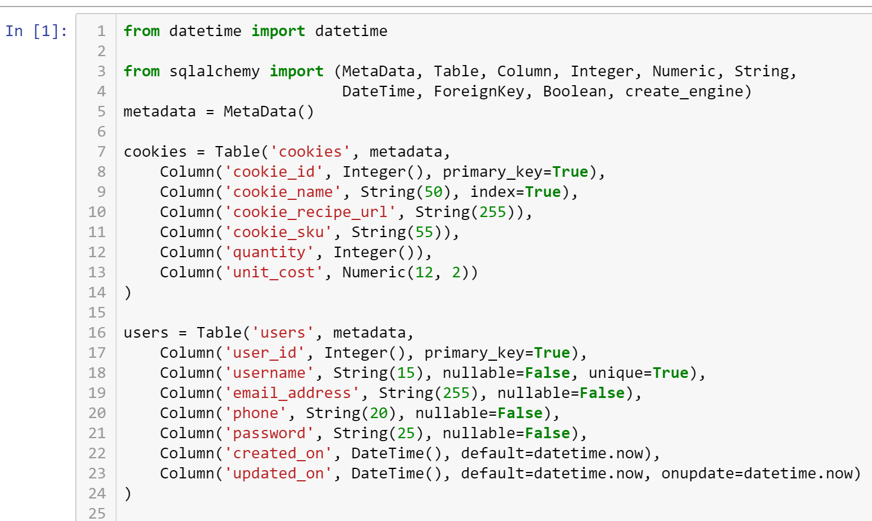

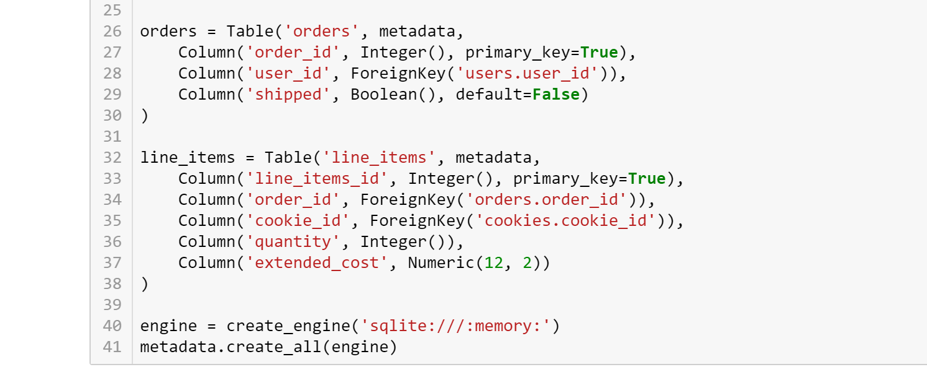

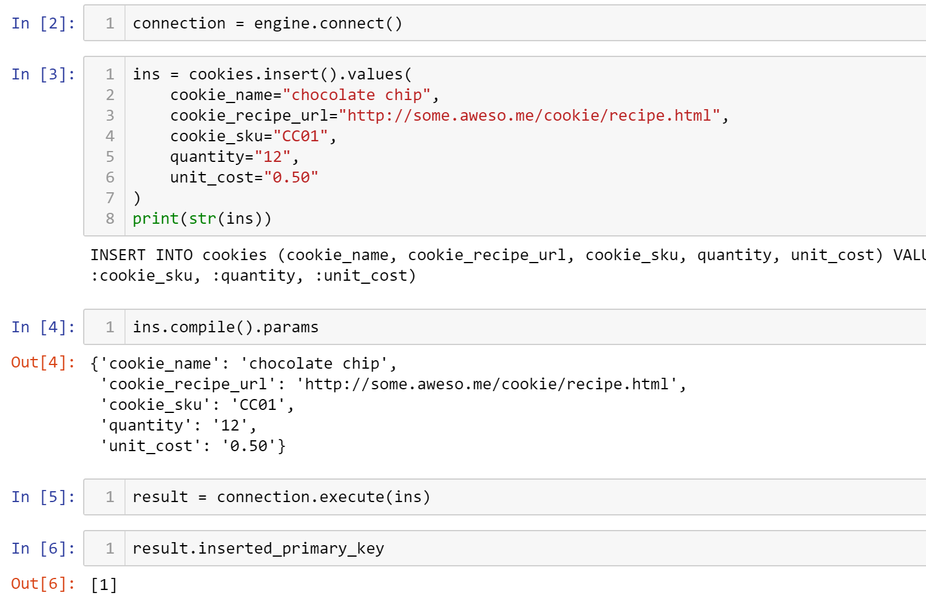

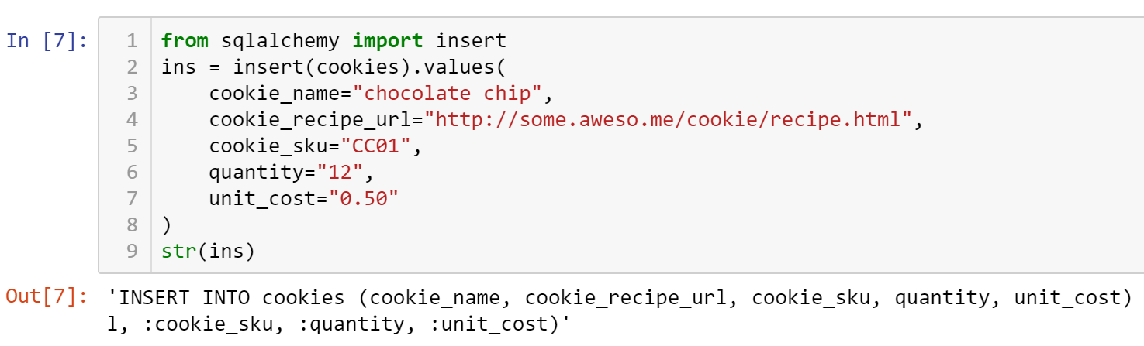

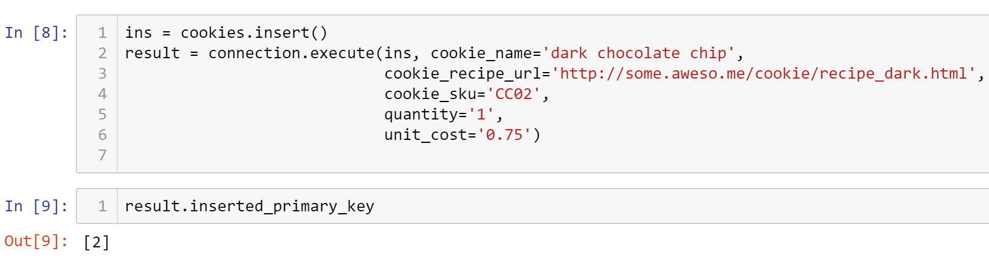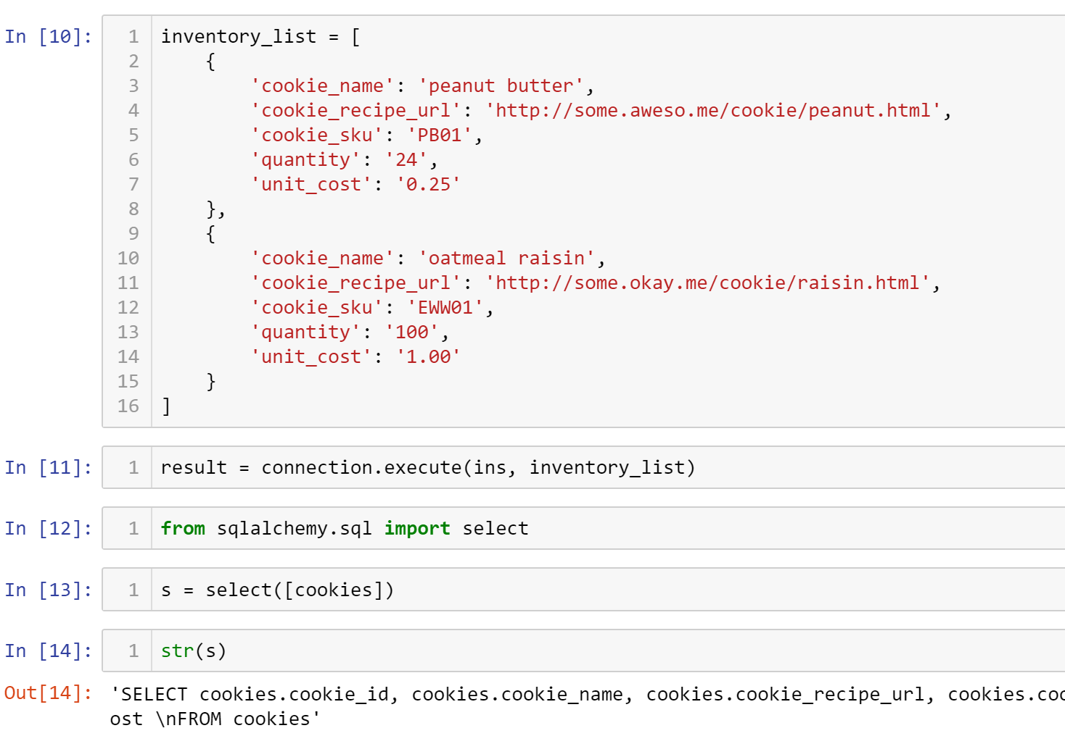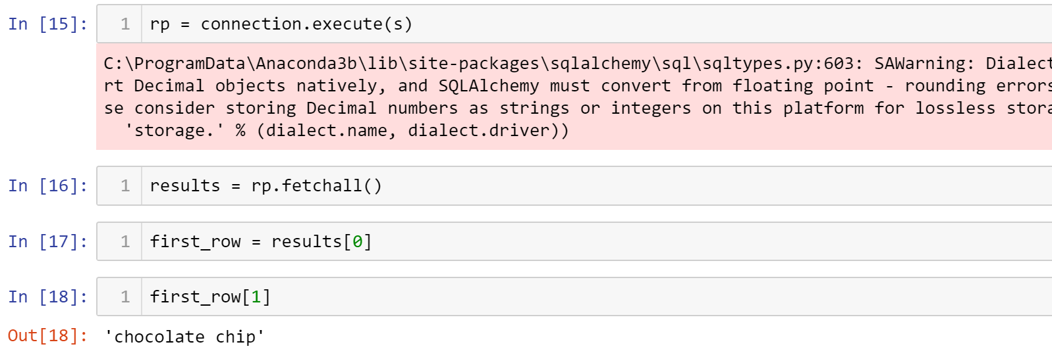

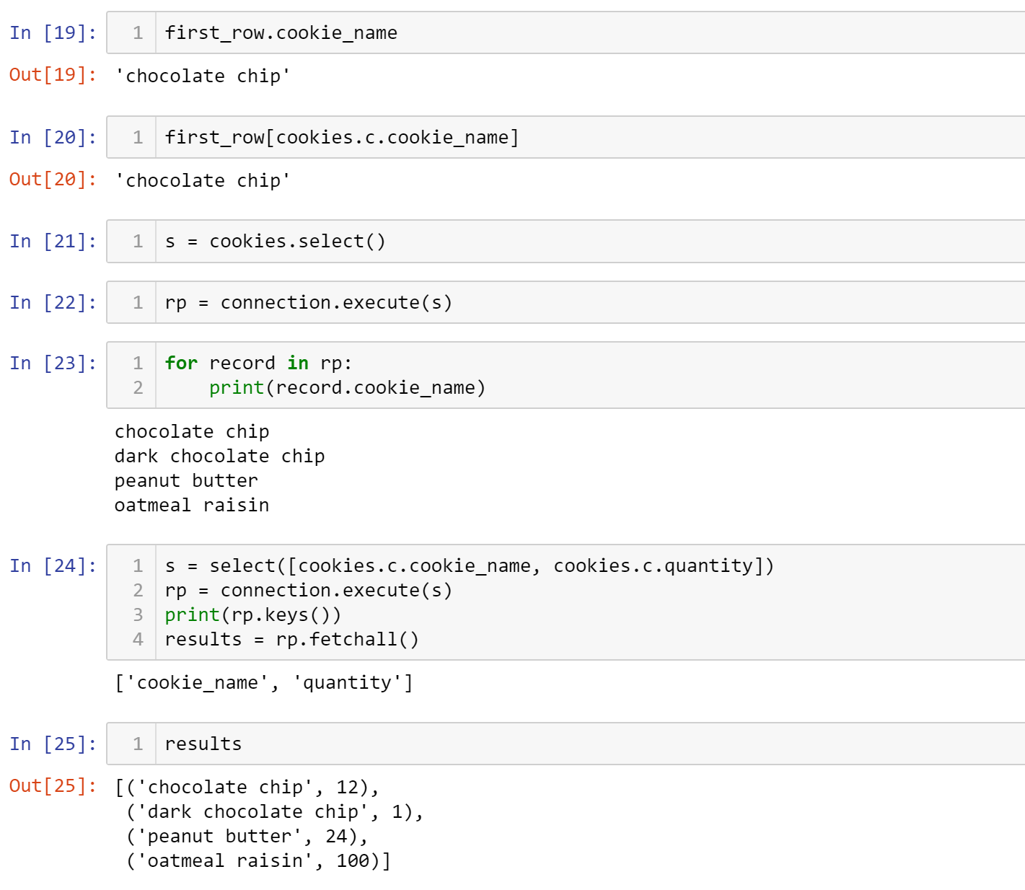

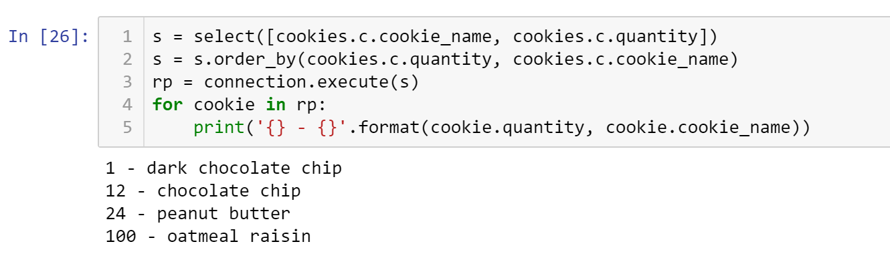

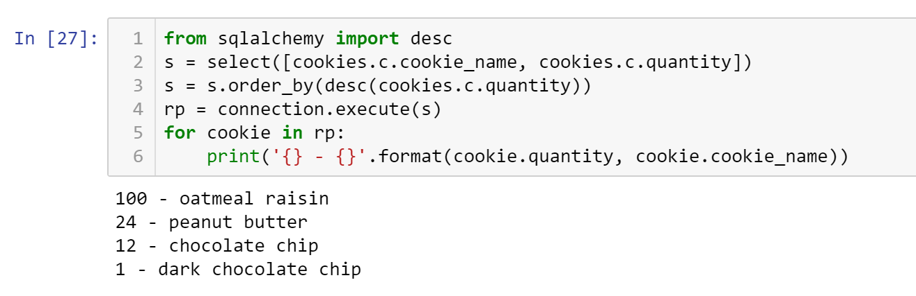

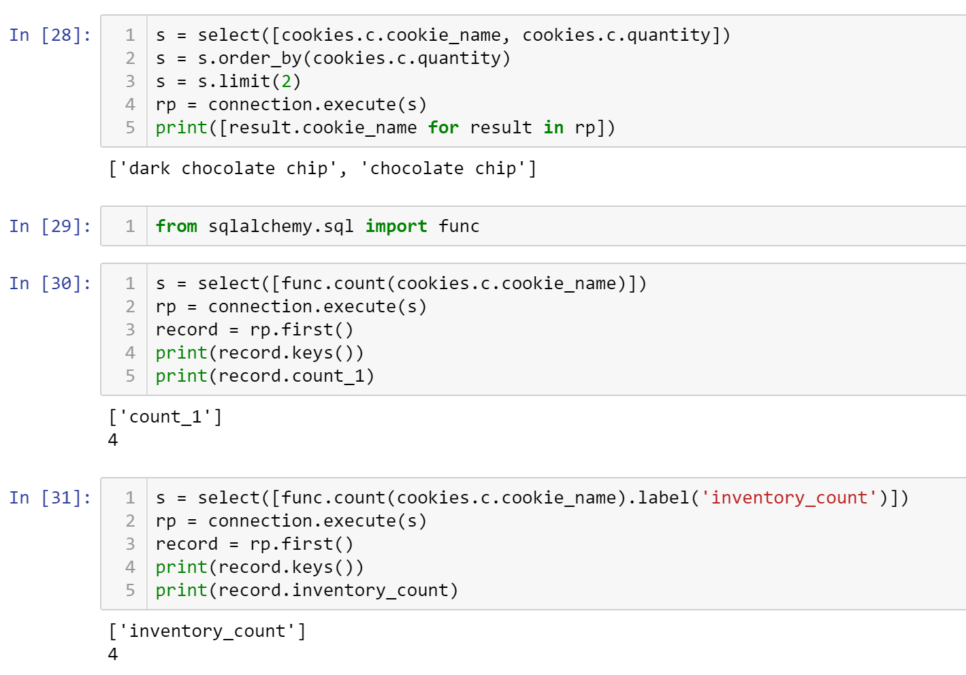

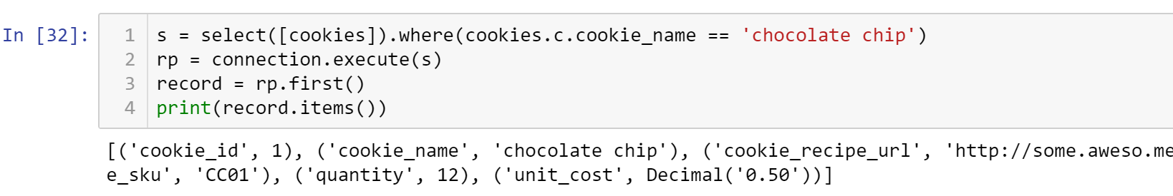

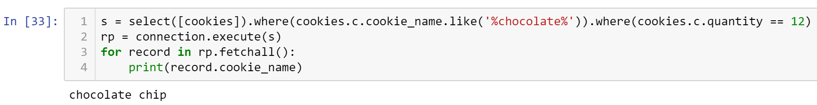

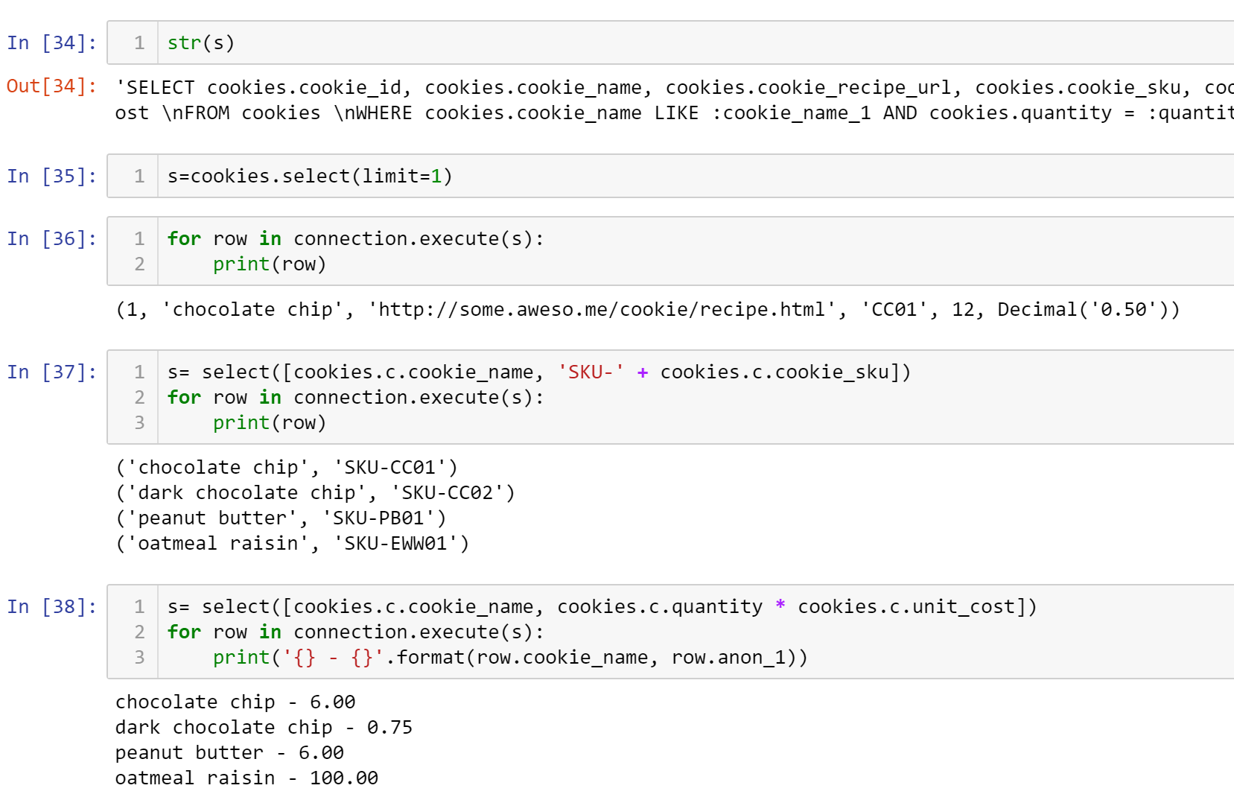

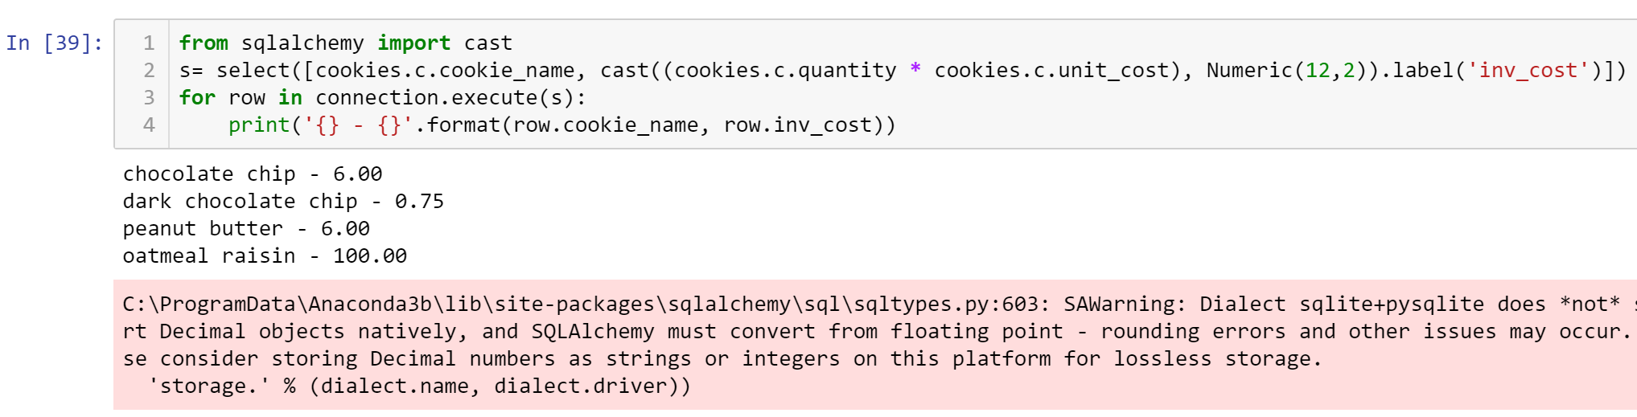

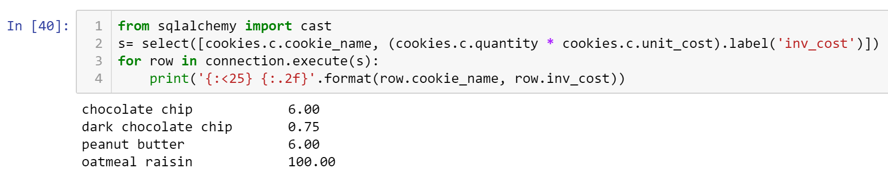

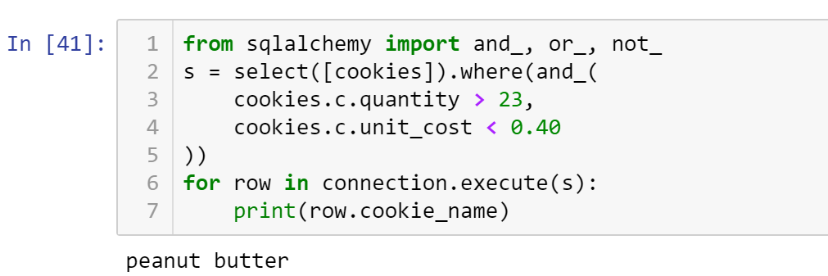

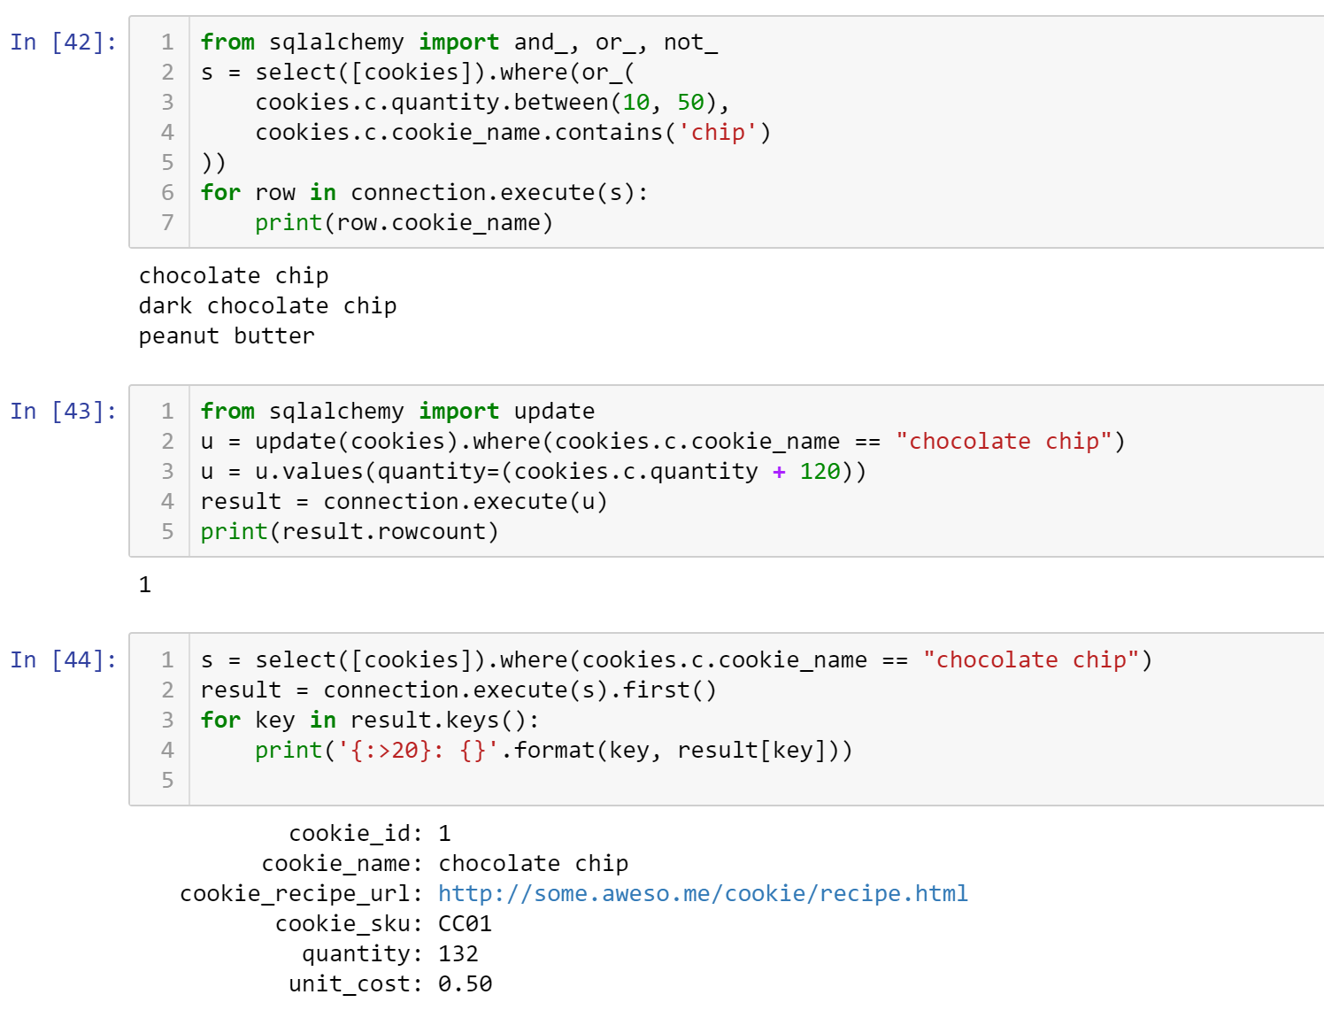

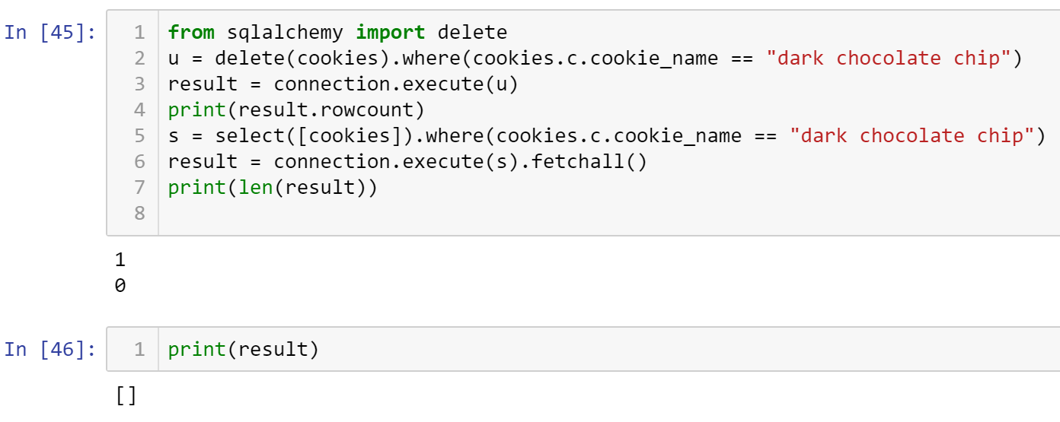

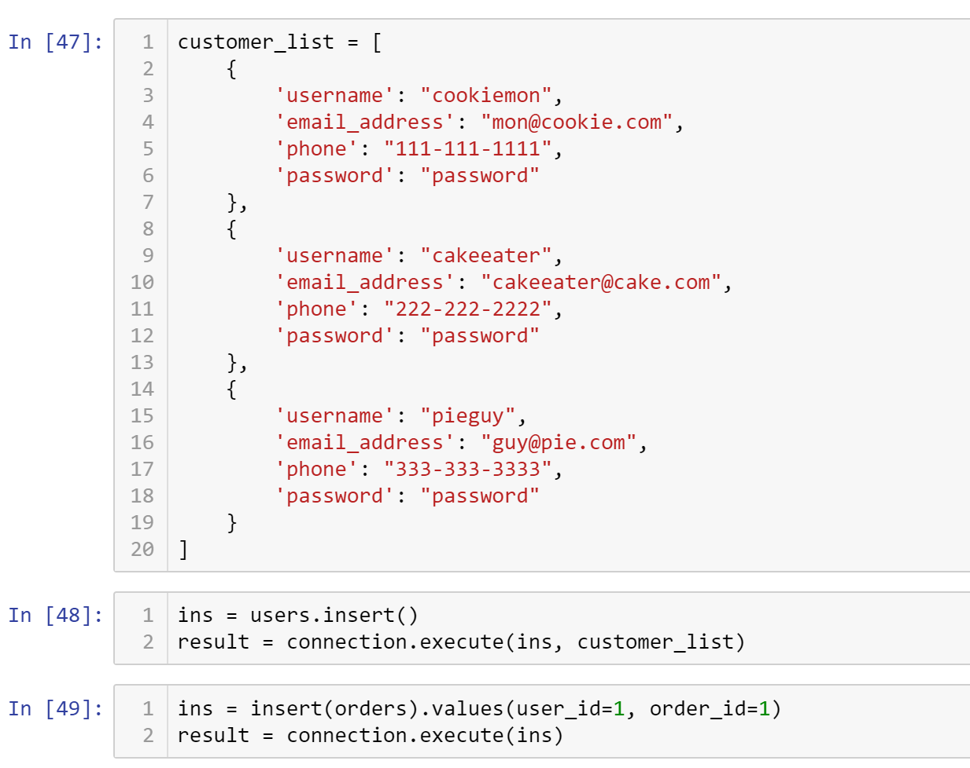

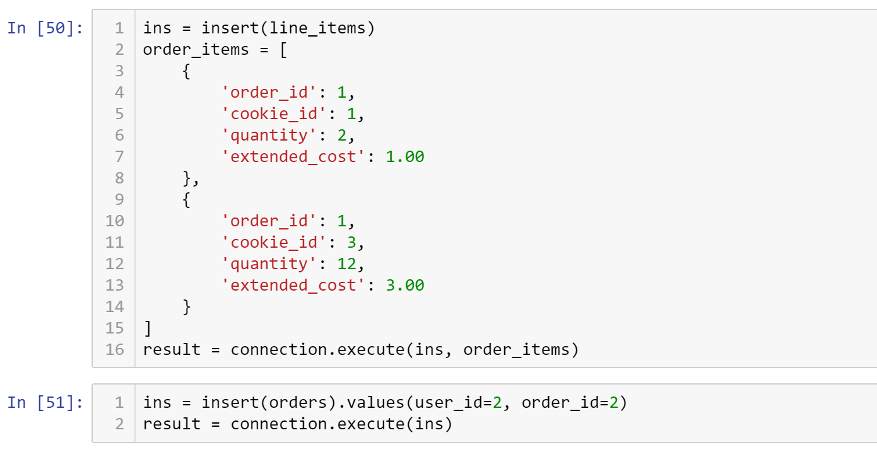

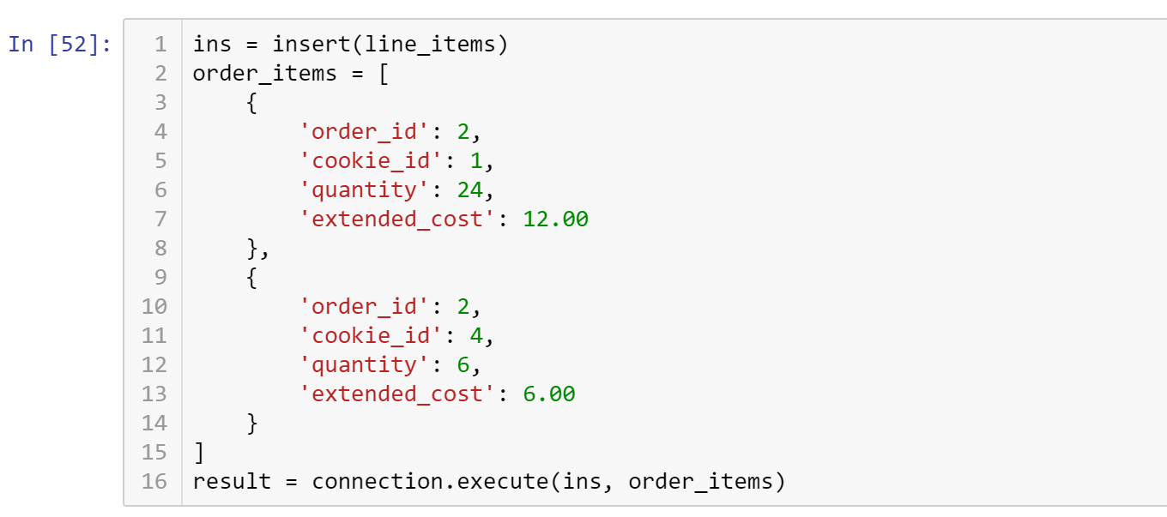

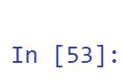

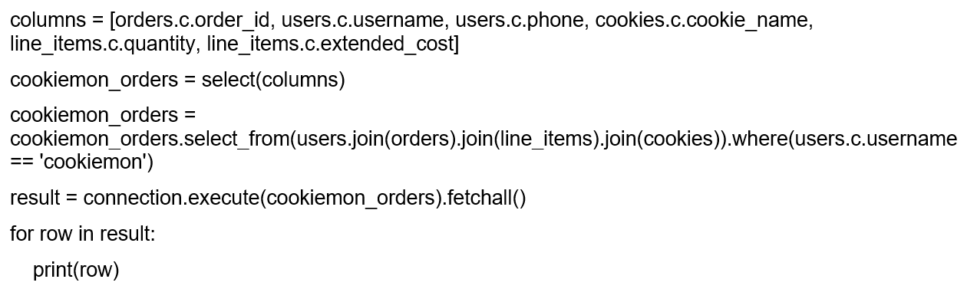

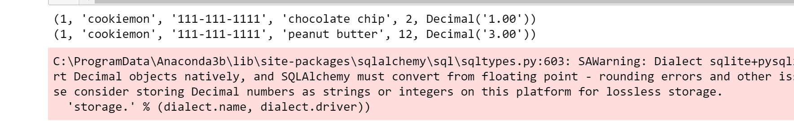

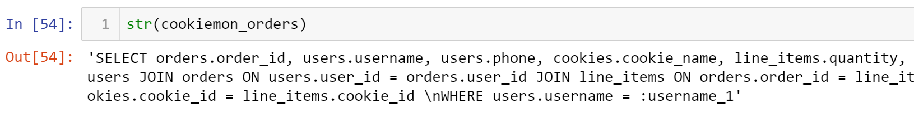

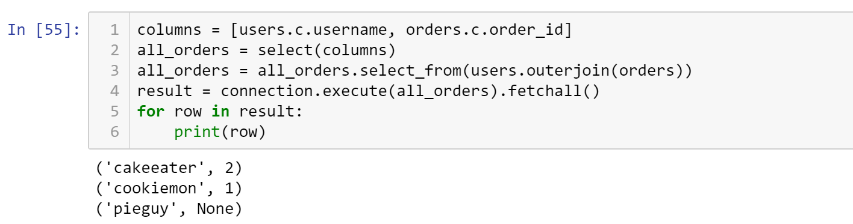

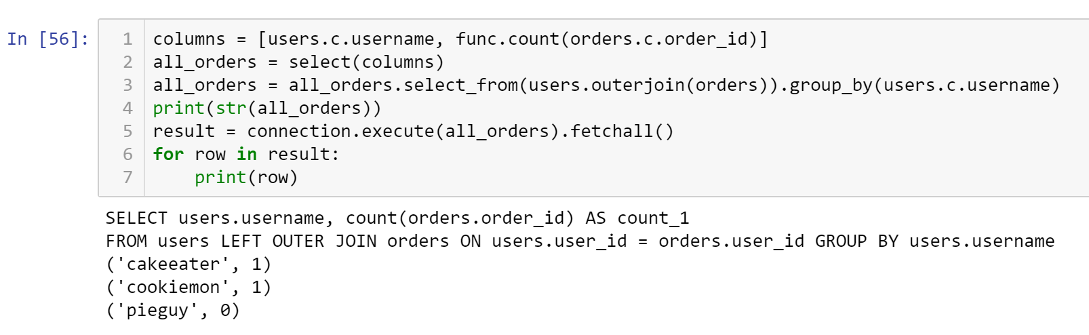



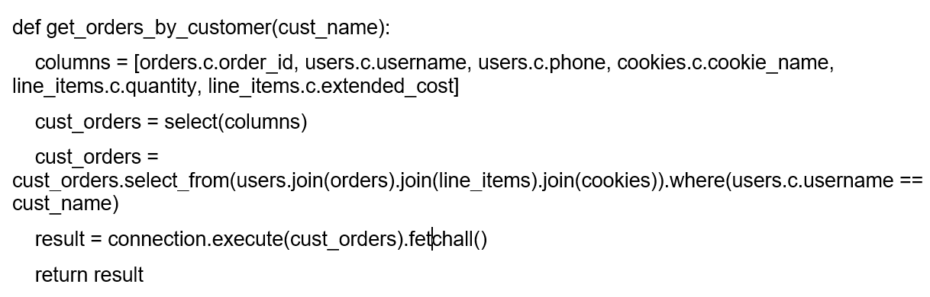

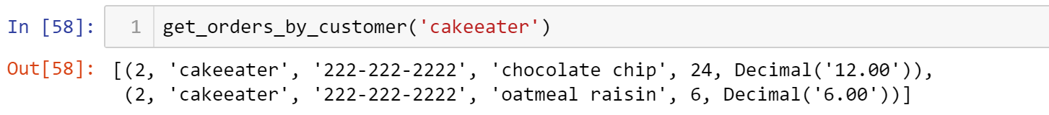

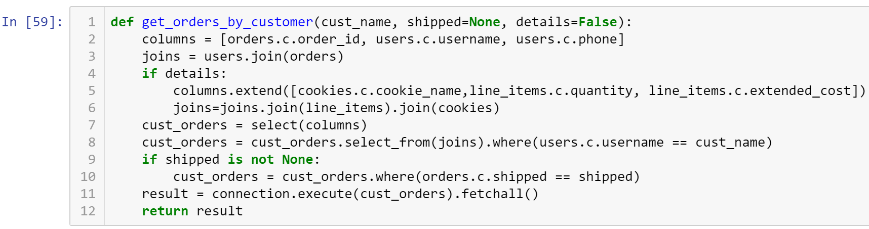

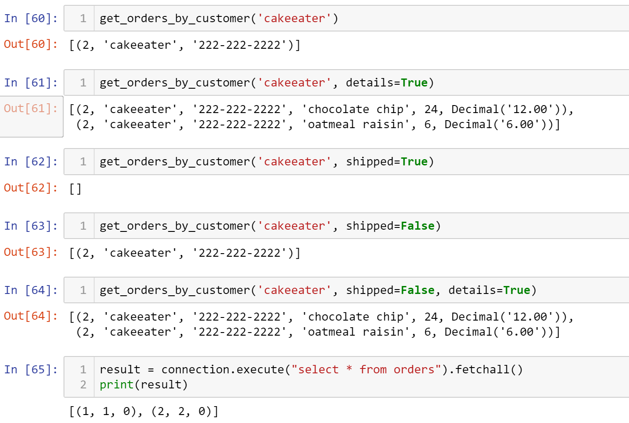

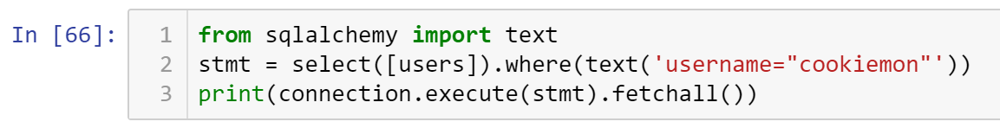

Out[66]:



* **Critical Thinking Section:** In your own words, write a paragraph (5 sentences or more) comparing and contrasting sending SQL request in Python versus SQL request in other programming languages.
* Place your answer here below:

|  |
| --- |
| Both SQL and Python both use similar SQL statements. The difference between SQL and Python is the fact certain pieces needs to be imported for Python to work. In SQL you don’t need to import different pieces. In Python, the queries are similar but different at the same time. For example, the “SELECT FROM” statement in Python is “select_from.” |

* Place your name at the bottom of your code, download your Python program in html format, and submit your work in Canvas.

**Important:** All submissions should be separate from other exercises and quests. Please do not lump all your answers into one document and re-using that same workspace to gain multiple points. Thanks.